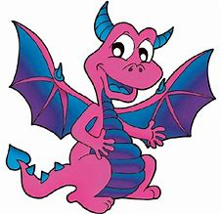  March | 2020
Sunday | Monday | Tuesday | Wednesday | Thursday | Friday | Saturday
1 | 2 | 3 | 4 | 5 | 6 | 7
 | PTA Spring Fund Raiser Ends  MP3 Interims sent home |  |  |  | School Spirit Day  School Colors
8 | 9 | 10 | 11 | 12 | 13 | 14
Spring Picture Day
Spring Book Fair
Library
15 | 16 | 17 | 18 | 19 | 20 | 21
 | Spring Book Fair  Library | Spring Book Fair  Library | Spring Book Fair  Library | School Spirit Day – Rock Your Socks Spring Book Fair  Library | School Closed  Professional Development
22 | 23 | 24 | 25 | 26 | 27 | 28
 |  |  |  | End of MP3  Multicultural Night  Time TBD | School Closed  Grading & Professional Development
29 | 30 | 31 | 1 | 2 | 3 | 4
At a Glance: | McVey Elementary School  3/6 – School Spirit Day – School Colors  3/13 – Spring Picture Day  3/13 – Spring Book Fair begins  3/19 – School Spirit Day – ROCK YOUR SOCKS  3/20 – School Closed – Professional Development  3/27 – School Closed – Grading & Professional Development |  | 